**Mongo DB – Face Prep   
 V. Dhruva Teja  
 22BCE7314**  
  
  
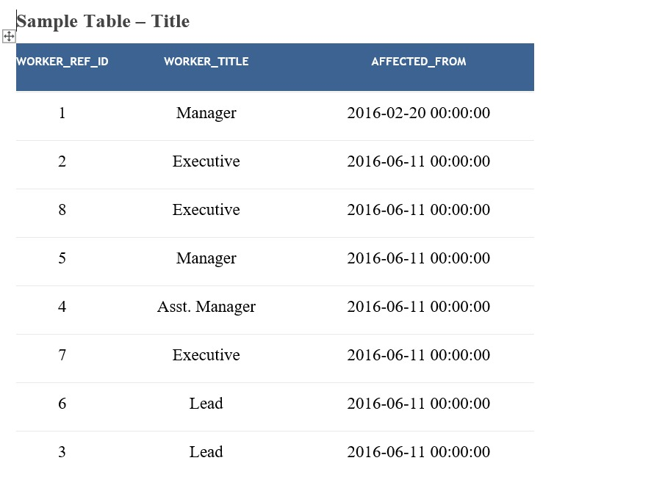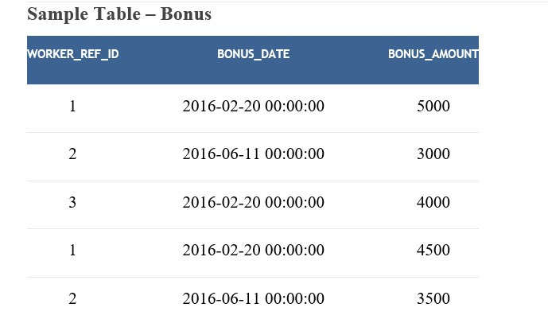

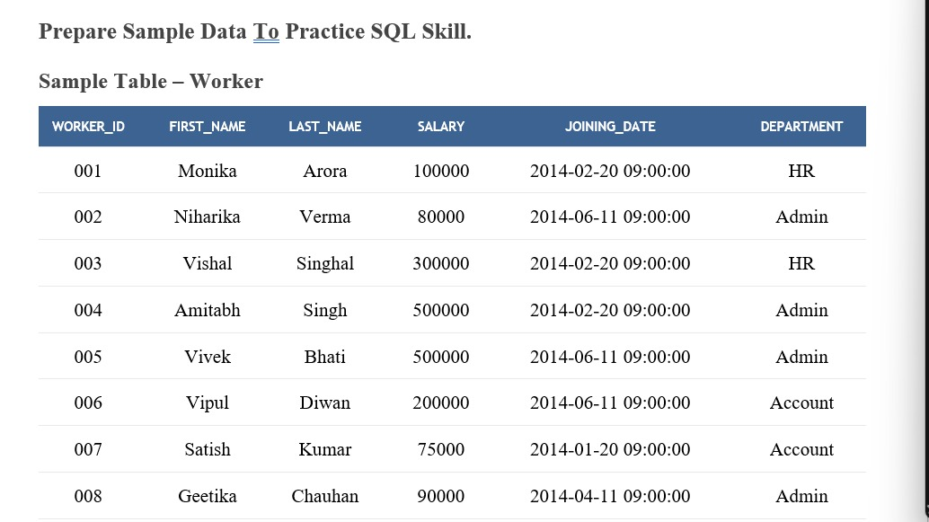

**Sql Code:**  
  
DROP TABLE IF EXISTS Worker;

DROP TABLE IF EXISTS Title;

DROP TABLE IF EXISTS Bonus;

CREATE TABLE Worker (

WORKER_ID INT,

FIRST_NAME VARCHAR(50),

LAST_NAME VARCHAR(50),

SALARY INT,

JOINING_DATE DATETIME,

DEPARTMENT VARCHAR(50)

);

INSERT INTO Worker VALUES

(001, 'Monika', 'Arora', 100000, '2014-02-20 09:00:00', 'HR'),

(002, 'Niharika', 'Verma', 80000, '2014-06-11 09:00:00', 'Admin'),

(003, 'Vishal', 'Singhal', 300000, '2014-02-20 09:00:00', 'HR'),

(004, 'Amitabh', 'Singh', 500000, '2014-02-20 09:00:00', 'Admin'),

(005, 'Vivek', 'Bhati', 500000, '2014-06-11 09:00:00', 'Admin'),

(006, 'Vipul', 'Diwan', 200000, '2014-06-11 09:00:00', 'Account'),

(007, 'Satish', 'Kumar', 75000, '2014-01-20 09:00:00', 'Account'),

(008, 'Geetika', 'Chauhan', 90000, '2014-04-11 09:00:00', 'Admin');

CREATE TABLE Title (

WORKER_REF_ID INT,

WORKER_TITLE VARCHAR(50),

AFFECTED_FROM DATETIME

);

INSERT INTO Title VALUES

(1, 'Manager', '2016-02-20 00:00:00'),

(2, 'Executive', '2016-06-11 00:00:00'),

(8, 'Executive', '2016-06-11 00:00:00'),

(5, 'Manager', '2016-06-11 00:00:00'),

(4, 'Asst. Manager', '2016-06-11 00:00:00'),

(7, 'Executive', '2016-06-11 00:00:00'),

(6, 'Lead', '2016-06-11 00:00:00'),

(3, 'Lead', '2016-06-11 00:00:00');

CREATE TABLE Bonus (

WORKER_REF_ID INT,

BONUS_DATE DATETIME,

BONUS_AMOUNT INT

);

INSERT INTO Bonus VALUES

(1, '2016-02-20 00:00:00', 5000),

(2, '2016-06-11 00:00:00', 3000),

(3, '2016-02-20 00:00:00', 4000),

(1, '2016-02-20 00:00:00', 4500),

(2, '2016-06-11 00:00:00', 3500);  
  
  
**Output:**

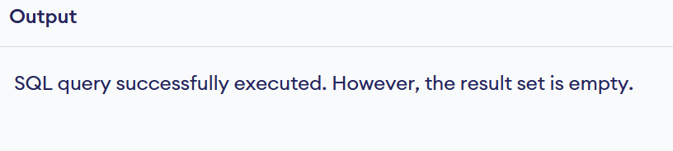

1) Write an SQL query to fetch unique values of DEPARTMENT from Worker table.  
SELECT DISTINCT DEPARTMENT  
FROM Worker;  
  
2) Write an SQL query to print all Worker details from the Worker table order by FIRST_NAME Ascending and DEPARTMENT Descending.  
SELECT *  
FROM Worker  
ORDER BY FIRST_NAME ASC, DEPARTMENT DESC;

3). Write an SQL query to print details of the Workers whose FIRST_NAME contains ‘a’  
SELECT *  
FROM Worker  
WHERE FIRST_NAME LIKE '%a%';  
  
4. Write an SQL query to print details of the Workers whose FIRST_NAME ends with ‘h’ and contains six alphabets  
SELECT *  
FROM Worker  
WHERE FIRST_NAME LIKE '_____h';  
  
5. Write an SQL query to print details of the Workers whose SALARY lies between 100000 and 500000  
SELECT *  
FROM Worker  
WHERE SALARY BETWEEN 100000 AND 500000;

6. Write an SQL query to print details of the Workers who have joined in Feb’2014.  
SELECT *  
FROM Worker  
WHERE MONTH(JOINING_DATE) = 2 AND YEAR(JOINING_DATE) = 2014;

7. Write an SQL query to fetch the count of employees working in the department ‘Admin’  
SELECT COUNT(*) AS Admin_Employee_Count  
FROM Worker  
WHERE DEPARTMENT = 'Admin';

8. Write an SQL query to fetch worker names with salaries >= 50000 and <= 100000.  
SELECT FIRST_NAME, LAST_NAME  
FROM Worker  
WHERE SALARY BETWEEN 50000 AND 100000;

9. Write an SQL query to fetch the no. of workers for each department in the descending order.  
SELECT DEPARTMENT, COUNT(*) AS Worker_Count  
FROM Worker  
GROUP BY DEPARTMENT  
ORDER BY Worker Count DESC;

10. Write an SQL query to print details of the Workers who are also Managers.  
SELECT W.*  
FROM Worker W  
JOIN Title T ON W.WORKER_ID = T.WORKER_REF_ID  
WHERE T.WORKER_TITLE = 'Manager';  
  
11. Write an SQL query to determine the 2nd lowest salary without using TOP or limit method.  
SELECT MIN(SALARY) AS Second_Lowest_Salary  
FROM Worker  
WHERE SALARY > (

SELECT MIN(SALARY)

FROM Worker

);  
  
  
  
  
  
  
12) Write an SQL query to fetch the list of employees with the same salary  
SELECT *  
FROM Worker  
WHERE SALARY IN (

SELECT SALARY

FROM Worker

GROUP BY SALARY

HAVING COUNT(*) > 1

);  
  
13. Write an SQL query to show the second highest salary from a table.  
SELECT MAX(SALARY) AS SecondHighestSalary  
FROM Worker  
WHERE SALARY < (SELECT MAX(SALARY) FROM Worker);  
  
14. Write an SQL query to show one row twice in results from a table.   
SELECT *  
FROM Worker  
WHERE WORKER_ID = 1  
UNION ALL

SELECT *  
FROM Worker  
WHERE WORKER_ID = 1;

15. Write an SQL query to fetch the first 50% records from a table.  
WITH RankedWorkers AS (  
 SELECT *,

ROW_NUMBER() OVER (ORDER BY WORKER_ID) AS rn,

COUNT(*) OVER () AS total_count

FROM Worker

)

SELECT *  
FROM RankedWorkers  
WHERE rn <= total_count / 2;  
  
16. Write an SQL query to fetch the departments that have less than three people in it.  
SELECT DEPARTMENT  
FROM Worker  
GROUP BY DEPARTMENT  
HAVING COUNT(*) < 3;  
  
  
17. Write an SQL query to show all departments along with the number of people in there.  
SELECT DEPARTMENT, COUNT(*) AS NumOfWorkers  
FROM Worker  
GROUP BY DEPARTMENT;

18. Write an SQL query to fetch the last five records from a table.  
SELECT *  
FROM (

SELECT *

FROM Worker

ORDER BY WORKER_ID DESC

LIMIT 5

) AS LastFive  
ORDER BY WORKER_ID;  
  
19. Write an SQL query to print the name of employees having the highest salary in each department.  
SELECT FIRST_NAME, LAST_NAME, DEPARTMENT, SALARY  
FROM Worker  
WHERE SALARY = (

SELECT MAX(SALARY)

FROM Worker AS W2

WHERE W2.DEPARTMENT = Worker.DEPARTMENT

);  
  
20. Write an SQL query to fetch three max salaries from a table.  
SELECT DISTINCT SALARY  
FROM Worker  
ORDER BY SALARY DESC  
LIMIT 3;  
  
21. Write an SQL query to print the name of employees having the lowest salary in accunt and admin department.  
SELECT FIRST_NAME, LAST_NAME, DEPARTMENT, SALARY  
FROM Worker  
WHERE DEPARTMENT IN ('Account', 'Admin')

AND SALARY = (

SELECT MIN(SALARY)

FROM Worker AS W2

WHERE W2.DEPARTMENT = Worker.DEPARTMENT

);